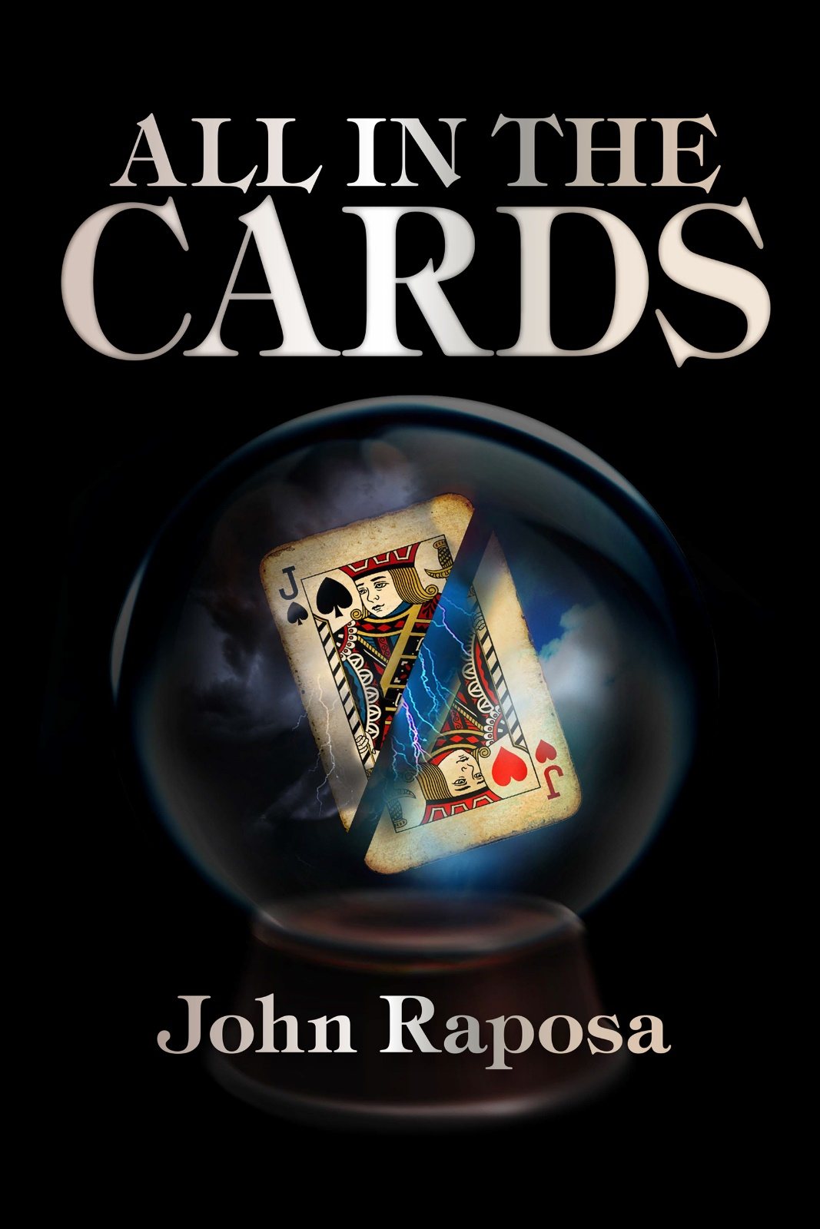

1
Danny
Present Day (12/9/2018)
A
S MY CAB rounds the corner, I can see terminal five ahead on the right. The payment for the cab ride is already neatly folded in my right hand. Given the amount displayed on the meter, my driver will be pleased. The clock on the screen reads 4:00 a.m., an ungodly time to be heading to LAX for a Sunday morning flight. While many people will be attending religious services, I’ll be hurtling eastward in a cramped metal tube. The way I see it, I’ll be closer to God than the pious churchgoers. Most of them will be looking to atone for sins less than twelve hours old.
Even at this hour, the curb is packed with vehicles unloading their cargo. My driver pulls up to the curb about fifty yards from the terminal entrance and waits in line.
“This is close enough.”
He nods and puts the car in park. I try pulling my left hand out of my pocket to grab my carry-on, but my hand is reluctant to release its contents. Old habits are hard to break. Finally, with a concerted effort, I drag my hand out and grab my bag. The cabbie turns around to get paid. I hand him the money, which he deposits directly into his shirt pocket.
“Have a nice flight, sir.”
He follows this with a smile, but the gesture doesn’t quite reach his eyes. Instead, his eyes register the same concern I caught periodically in the rearview mirror during our brief trip. Bemused by his behavior, I reach for the door handle and exit the vehicle.
The early morning air feels mild as I step onto the curb. It’s a far cry from what I will face in New York City later today. The temperature isn’t expected to reach twenty degrees, and there’s a good chance of snow. What did I expect in December? As I approach the terminal doors, I see my reflection in the glass. I’m a bit taken aback by the image. The man staring back looks older than forty-five. They say stress accelerates the aging process. If that’s the case, then I should be the poster child. Behind me, I see my cab driving off. Staring at my reflection, I can understand the driver’s concern. Not only do I look haggard and sickly, but I appear to have a crazed look.
“Sir, is everything all right?”
The voice from behind jolts me out of my thoughts.
“I’m sorry. I’m merely lost in thought. I can’t function until after my first cup of coffee.”
The young woman politely smiles as she patiently waits for me to enter the terminal. I end the awkward encounter by turning around and walking through the automatic doors.
As suggested by the congestion outside, a fair number of travelers are scurrying around. Scanning the interior, I spot the nearest arrival/departure monitor off to my right. I make my way to the monitors and begin searching the bank of departure screens. It takes a few seconds before I see the cluster of New York departures. Finding my flight number, I look across to see the ominous word, ‘canceled’. This is not the way I wanted to start my Sunday. Out of habit, I glance down at the left side of my jacket and utter a familiar question.
“You wouldn’t have anything to do with this, would you?”
“Excuse me?”
A familiar voice comes from my left. It belongs to the same woman who followed me into the terminal. Apparently, she overheard me talking to myself. I give a sheepish look and attempt to explain, but the young lady eyes me critically and hurries off in the direction of the security line. She leaves me standing there with my mouth agape. Taking an exasperated breath, I look for the nearest escalator, which will take me to ticketing. I have more immediate concerns at the moment. If the woman thinks I have a few screws loose, she can get in line behind a host of others who have shared her opinion over the years.
At the top of the escalator, I see my airline on the far side of the terminal. The lines aren’t bad, considering the size of this airport. Fortunately, I arrived somewhat early this morning. I bet there will be a mad rush of people trying to find flights once they discover the cancellation. I take my place at the back of the line and watch the ticket agents attending to their customers. They all appear to be enjoying their jobs as they greet each traveler with a smile and then repeat the same mundane tasks of checking tickets and luggage. It takes a special person to project a pleasant façade while dealing with the public before 4:30 a.m. on a Sunday. Finally, it’s my turn to be assisted.
“Good morning, sir. What can I help you with?”
“I was on the canceled 5:40 a.m. flight to JFK. Are there any seats left on the 7:00 a.m. flight?”
“I’m not sure, sir. Can I have your license, and I’ll check for you?”
I hand over my identification and anxiously wait. Lord knows why I’m worried. Truth be told, I could take any flight today.
“It looks like you’re in luck, Mr. Myers. There are a couple of seats left.”
“You wouldn’t happen to have an aisle or a window seat?”
“I’m afraid not. Unfortunately, there are only middle seats available. Would you like me to book you on the flight?”
“Yes, please.”
“No problem. Will you be checking any baggage?”
“No. I just have a small carry-on.”
“That’s good because there will be a shortage of overhead space on this flight.”
Of course, there is. Passenger comfort isn’t a priority these days. Flights are overbooked, there’s no room for luggage, and you’re lucky to get a few pretzels on a long flight.
“Okay, Mr. Myers, I have you booked on the 7:00 a.m. flight. Here’s your boarding pass. Your flight will begin boarding at gate 57 at 6:30 a.m. Have an enjoyable flight.”
She immediately flashes her perfect smile and looks over my shoulder for her next customer. I look at my boarding pass and let out a chuckle.
“Row 13, huh? Well, I guess someone has to sit there. The problem is, if my number comes up, it’s an unlucky day for everyone.”
My ticketing agent’s smile falters temporarily,
“Sir, our airline has one of the best safety ratings. I’m sure you have nothing to worry about.”
I contemplate explaining my weak joke but decide against it. Airline personnel understandably lack a sense of humor. I thank the gate agent, pick up my carry-on, and head to the security line.
The security area has several positions open, so I quickly navigate the rat maze. After passing through the security checkpoint, I find myself waiting in a line to have my bag x-rayed and my body scanned. Looking up, I see a gentleman being assisted in a wheelchair. The poor guy has a large cast on his leg. As I watch the man stand and prepare to go through the metal detector, I get a clear look at his face. I’m jolted by the odd sensation that I know him. The memory escapes me as I watch the man being led away from the full-body scanner and through the metal detector.
“Sir, you need to remove your shoes.”
I’m snapped out of my reverie by a nearby voice. The line has moved forward, and an exasperated security agent is glaring at me. The conveyor belt is empty. Reaching for the top plastic bin, I note the annoyed expressions of the travelers in the queue behind me. I quickly remove my shoes and place them in the container. My small carry-on follows.
As I head toward the full-body scanner, I see a security agent passing a wand over the same man I previously saw in the wheelchair. An image finally flashes in my mind, and I recall where I’ve seen that face. The face belongs to a kid I grew up with many years ago.
“Hey, Brooks!” I blurt out.
The man with the cast glances in my direction and then returns his attention to the security guard after exhibiting no recognition whatsoever. I guess it was a bit of a stretch to think I’d meet a childhood friend here. A throat clears in front of me. I turn to see yet another agitated security guard standing on the other end of the empty body scanner. It looks like I’m holding up the line once again.

My flight is already boarding by the time I reach my gate, but my boarding group hasn’t been called yet. Apparently, my gamble to wait for the coffee shop to open, along with several other weary passengers, paid off. My long wait in line was rewarded when I saw that the shop carried chocolate-frosted donuts. I was able to enjoy my coffee and donuts as I took my time walking to my gate.
I take a seat so I can enjoy the rest of my coffee. It always amazes me how everyone is in such a hurry to get in the boarding line, only to stand and wait. Once their boarding pass is scanned, they will be rewarded with a line at the end of the jetway. After boarding the plane, they must remain seated while the rest of the passengers board. I’m more than happy to stay away from the jostling madness. The more time I can avoid being stuck in that flying petri dish, the better.
About ten minutes later, my group is called. I finish the last few sips of coffee, toss the cup away, and make my way over to yet another smiling airline employee. They must take a special class in airline school to appear so jovial. After having my pass checked, I make my way down the tunnel and onto my ride to New York.
As I walk up the aisle, several seated passengers look up and give me that, ‘please don’t sit here look.’ The way I see it, you can either have the 350 lb. businessman, who will hog both armrests, or me. This thought has me chuckling as I reach row 13. The window seat is already occupied by a young man wearing a set of bright red headphones. A faint bass beat is leaking out the sides of the headphones, probably along with some brain matter. I’m pleasantly surprised to see that the overhead compartment above my seat is relatively empty. I stow my carry-on and plop myself down into my home for the next five and a half hours. Now it’s my turn to display the ‘do not sit next to me’ look, which is silly since this flight has assigned seating.
Bleary-eyed travelers file up the aisle, some of them meeting my unwelcoming stare and thankfully continuing past my row. Eventually, an attractive blonde boards the plane and begins to saunter up the aisle. My repellant look quickly morphs into a more welcoming visage. I’m rewarded when she stops at my row, displays a provocative smile, and then reaches up to place her luggage in the overhead compartment. Her attire hints at a professional field. She’s dressed in a tight-fitting black skirt cut above the knee, modest black heels, and a white silk blouse. As she stretches to place her luggage inside, her blouse opens, revealing a white lace bra. I feel like a schoolboy sneaking a peek at his teacher. I turn quickly away and glance out the window. When the sounds above stop, I nonchalantly turn back to see my new seatmate preparing to sit down. She gives another warm smile as she crouches down into her seat, providing me with another glimpse in the process. She gracefully buckles her seatbelt and gets herself situated before looking in my direction.
“It looks like we’re going to be neighbors for a bit. My name is Melanie. My friends call me Mel.”
She reaches her hand over. I’m temporarily rooted in my seat as my mouth goes dry. Her blue eyes remind me of Leigh’s. They’re bright and full of life. Some people have smiling eyes that are so alive they light up a room when they walk in. While most people merely blend into their surroundings. Then there’s the group whose eyes are dim. It’s almost as if they are dead inside. Their eyes match their lifeless demeanor. Leigh could cheer me up by simply looking at me. I could sense the effect on others when she came into contact with them. Returning to the present, I attempt to save myself.
“Nice to meet you, Mel. I’m Daniel, but you can call me Danny.”
I reach over and give her hand a friendly shake. We both face forward and settle into our thoughts as we watch the remaining passengers board. A comfortable silence passes as the plane taxis from the gate and makes its way to the runway. I must have zoned out because I hear Mel’s muffled voice.
“Do you like to play cards?”
“Excuse me?”
She indicates down with her eyes.
“I saw your deck of cards and assumed you liked to play. I love to play cards myself. High-low-jack is my favorite.”
I look down at my lap to see my long-time companion in my left hand. I have no recollection of reaching into my pocket to take it out. This doesn’t surprise me anymore. I commonly do this, especially during stressful situations. I’m not very fond of take-offs and landings. I’d say it’s a bad habit, but that would be a lie. I know it goes way deeper than that.
“This old deck and I have a long history.”
“Then it’s a good thing we have a long flight ahead of us. I’m all ears.”

2
danNY
7/31/1987
(Nine of Spades)
T
HE LONG AWAITED day has finally come. The County Fair is tonight. It always starts on the last Friday of July and runs for three days. Depending on when it falls, it can mark the end of summer for the kids in the area since school can start as early as the following week. This is one of those years, so the arrival of the fair is somewhat bittersweet. Regardless, it has always been my favorite weekend of the summer, except for a few years ago. That year, a huge storm came through and damaged a bunch of tents and rides, causing the fair to be canceled. I remember moping around the entire weekend. Fortunately, the weather today and for the whole weekend is supposed to be sunny and hot.
For a couple of reasons, I thought the day would never come. First of all, it’s the thirty-first of July, so it’s the latest the fair could start. However, the most important reason I’ve been looking forward to this day is that my parents are letting me go without them for the first time. Not only that, but I get to take my girlfriend, Leigh Ann. Somehow, we were able to convince her parents to let us go together. Granted, we have to be home by 10:00 p.m., but we aren’t going to complain. Given the sun doesn’t set until 9:00 p.m., we’ll have less than an hour of darkness. I plan to save some of the scarier rides until the end of the night. Last year, Leigh practically sat on my lap while our car went through the Tunnel of the Dead.
My parents will be taking my younger brother Derek and me tomorrow night. Derek is only seven years old, so he can only go on the kiddie rides. Leigh is going to try to get her family to take her younger brother Will tomorrow night. This way, we can ‘bump’ into each other and hopefully get some alone time.
Leigh’s a great girl. We’ve been dating since the end of seventh grade. We jokingly talk about what it will be like when we’re older with kids of our own. We vow to be more lenient than our parents. I definitely won’t make my kids come home at 10:00 p.m. from the fair.

After driving my parents crazy all afternoon, I’m finally walking to Leigh’s house to pick her up. Our house is on Nottingham Drive, west of Seymour High School, where Leigh and I will be going next month. Leigh’s family lives just south of my house on Lady Marian Drive. Years ago, town planners must have thought it was a great idea to name the streets after characters and places in the Robin Hood book. I used to think it was cool when I was younger. Now, it seems corny. The fair is west of our neighborhood on Route 258. At night, I can see the glow of the lights above the trees from my house. If the wind is blowing from the west, I can hear the sounds of the fair through my bedroom window.
The smell of food being grilled hits me as I walk toward Leigh’s house. People are probably having an early supper outside before heading to the fair. I tried not to pig out at dinner in order to leave room for snacks later on. Turning down Leigh’s street, I see her house on the left. Her family’s two-story home is similar to a few others in the neighborhood.
The lawn in her front yard is brown due to the lack of rain. The town has imposed a watering ban as a result of the drought. On the bright side, I haven’t had to mow our lawn in almost a month. Upon reaching the top of her steps, I open the screen door and knock on the front door. I glance at my watch and see that it’s a few minutes before six. I always like to be on time, which is another thing Leigh and I have in common. I’m glad she’s not like my mom. My dad is always pacing around the house while my mom gets ready. Between choosing an outfit, applying make-up, and curling her hair, Dad’s at his wits end by the time she comes down the stairs. Leigh doesn’t wear any make-up, and her summer wardrobe consists of shorts, t-shirts, and sneakers.
The door finally opens, and Mrs. Jenkins appears in the doorway wearing her ever-present smile. Leigh gets her smile and her blue eyes from her mom. Her fiery temper is all dad.
“Good evening, Danny. Come on in.”
“Hi, Mrs. Jenkins.”
Mrs. Jenkins moves aside to let me inside. From the top of the stairs, I hear Leigh yell down.
“I’m all set, Danny. Let’s go.”
“I guess my daughter is anxious to get to the fair. Have a good time, kids.”
“Bye, mom.”
“Be home by ten.”
Leigh rolls her eyes in response to her father, who sounds like he’s in the living room upstairs.
“I know, Pop.
Leigh comes hurrying out the door before her mom can plant a kiss on her head. I step aside so I don’t get knocked over.
“C’mon, Danny.”
I give Mrs. Jenkins a quick shrug and wave before turning to follow Leigh. I eventually catch up with her at the end of the walkway.
“What’s the rush?”
“Sorry, but I couldn’t wait to get out of there. My dad was starting to drive me crazy with my curfew.”
Leigh slows down her pace as we head off toward Route 258.

Even though the fair has been pretty much the same as in previous years, tonight has been special because I’ve been able to experience it alone with Leigh. The two of us had our hands stamped as soon as we walked in, and we wasted no time buzzing from ride to ride. The past few hours have been a blur of rides and snacks. The night almost took a turn when Leigh started to feel sick on the Spinning Teacups. The ride ended just in time. I thought she was going to puke her fried dough all over me. We hurried off, and after a few sips of my soda, the color slowly returned to her face.
“How ya feeling?”
“Much better. But I think that’s enough spinning rides for me tonight.”
She gives me a grateful smile as she slips her hand into mine. I give her hand a reassuring squeeze. The two of us head off, walking hand-in-hand. I must admit it’s also fun simply walking among the rides and vendors, soaking up the atmosphere. The air is filled with an assortment of scents. Even though I’ve had my fill, my mouth starts to water as I walk by the freshly popped popcorn and roasted peanuts. These smells are quickly replaced by the scent of wild animals and hay. A nearby vendor tries his best to lure us into his game.
“Be a hero. Win a stuffed bear for your girl.”
I don’t even look over. I’ve been fooled by this guy before. The shot seems easy, but the basket is about the same size as the ball. They also put so much air in the ball that it goes flying if it merely touches the rim. So Leigh and I keep on walking, content with enjoying the sights and sounds.
A short time later, Leigh lets go of my hand and points to something down a little way on our left.
“Danny, let’s go in and give it a try.”
She’s gesturing toward a sign hung outside a small tent. The sign attempts to look mystical, but similar to other games in the fair, looks can be deceiving. The fancy lettering surrounding a hand reads, ‘Madame Palmieri, The Future is in Your Hands.’
“She’s a fake, Leigh. It’s all a scam.”
“I know, Danny, but it will be fun to see what story she comes up with for our future.”
Before I can respond, I see a tall kid step out of the tent. He walks deliberately toward the pathway we are on with his head down. I can’t see his face from this distance, but the way he walks reminds me of Brooks, who plays on my baseball team. As he passes by the sign, the light gives me a better look at his face.
“Hey, Brooks! How’s it going?”
Brooks stops and looks in our direction. His face registers no emotion as he appears to look through us. Then, he abruptly turns and starts running down the lane. As I’m watching my classmate sprint away, I hear Leigh’s voice to my left.
“Wow, that was weird. He looked like he’d seen a ghost.”
“Maybe it wasn’t ‘fun’ for him to hear about his future?”
Leigh stares at me for a few seconds as if she’s trying to pick the best way to respond. Eventually, she shakes her head and chuckles.
“I thought you didn’t believe in this stuff. Brooks was probably spooked about something else. C’mon, it will be fun. I promise.”
“I’m not getting my palm read. My hands are all sticky from the fried dough.”
By the renewed excitement in her eyes, I can tell I’ve lost this discussion. The smirk on her face signals that she knows she’s won. My left arm almost gets pulled out of its socket as she leads me toward the tent. Unfortunately, there’s no line I can use as a final excuse to get out of going.
Plastic beads hang in the doorway, and the sharp smell of incense greets us as Leigh drags me inside. I can feel my nose already getting stuffed up by the strong scent. I’ll probably be sneezing for the rest of the night after we leave here. A middle-aged woman wearing a purple robe covered with silver stars sits behind a small table draped with a purple tablecloth. A matching kerchief is tied around her head, and she has large silver hoop earrings dangling from her ears. Her makeup is caked on, and she has purple eyeshadow matching her long fingernails.
The woman looks up as we enter. She appears troubled but quickly recovers and offers a strained smile. Her left hand reaches into a white ceramic bowl and lifts out a grape, which she deposits into her mouth. She chews for a few seconds and then spreads out her arms.
“Greetings. Your future begins here.”
I fight the urge to laugh, but I expect the look on my face betrays my true feelings. As if sensing my doubt, the so-called psychic turns to Leigh.
“Come. Bring your boyfriend over here and sit down.”
Leigh glances over at me with a satisfied smirk. Don’t tell me my girlfriend is starting to buy this crap. We walk over and sit in the two seats across the table from the woman. The woman dramatically reaches into the bowl and pulls out another grape. She seems intent on drawing out our visit.
“Before we begin, there is a small matter of compensation.”
There is a price list on the table enclosed in a plastic frame. She apparently offers more extensive services than merely reading palms. So I’m somewhat relieved when Leigh only pulls out a five-dollar bill from her pocket.
“We would both like to have our palms read.”
Disappointment temporarily flashes in the woman’s eyes as the slim hope of swindling a bit more cash evaporates. She reaches over, deftly plucks the bill from Leigh’s hand, and places it in a pocket of her robe. She then proceeds to sit there studying us. Then, just as I’m beginning to feel uncomfortable, she begins her charade.
“I sense a strong bond between you two. The spectral forces are strong. A purple aura surrounds you. Instead of observing the future in your palms, I have something reserved for kindred spirits such as yourselves.”
It takes all of my willpower to keep from giggling. Instead, I concentrate on pretending my face is made of stone. At this point, I might as well go along with this so Leigh can at least enjoy the performance.
The woman reaches down next to her. I can’t see what she’s doing, but I hear the squeak of a lid opening. After rummaging around for a few seconds, she shuts the lid and straightens up. In her hand is a tattered deck of cards. One half of the box is dark red, while the other half is bright gold. She slowly opens the box, pulls out the deck, and begins shuffling the cards. The backs of the cards are decorated in a similar fashion to her robe. They are deep purple with silver stars. Her hands are very adept at shuffling. As I watch the cards, I begin to feel a bit light-headed.
Pulling my eyes away, I look up at her. Her face has transformed. She looks younger and more beautiful. She has also entered a trance-like state as she continues to shuffle. Eventually, she stops, places the deck in her right hand, and then sweeps them in an arc across the table. Her eyes are glistening with excitement. They are now crystal blue, and I feel drawn to them. I try to recall if they were this color when we first sat down. I force myself to look over at Leigh. She is rigid, and her eyes are riveted on the psychic. My instincts tell me to grab Leigh and rush out of here, but my arms feel heavy, and my feet are rooted to the ground. I hesitantly turn forward but force myself not to look into the woman’s eyes.
Her hands reach out and hover over the arc of cards. I take a risk and glance up at her face. Thankfully, her eyes are closed, and her head is tilted up slightly. I return my gaze to her hands, which continue to sweep back and forth slowly. Before long, the trance-like feeling returns as I become mesmerized by her hands. Her hands abruptly stop and remain rigid over the cards. Her right hand slowly reaches down and flips one of them over. The card is different from your typical playing card. It has the number and symbol for the three of hearts in two of the opposing corners, but the center of the card contains a picture. The picture shows the face of a worn teddy bear. Recollection immediately hits me.
“Hey, that’s Dirty Bear. I had him when I was a little kid.”
My excitement snaps Leigh out of her trance.
“Are you sure, Danny?”
“I’m positive. There’s the worn patch on his cheek. See how his ears have been sewn back on. My mother had to reattach them because I used to play with them before I fell asleep.”
The fortune teller nods her approval and then starts sweeping her hands back and forth. Her eyes close, and her head tilts back once again. I anxiously look down and follow her hands. Eventually, they stop, and she turns a card over off to the right. It’s another three, but this time it’s a diamond. The picture inside shows the front of a green Schwinn bicycle. A baseball card is attached to a spoke in the front wheel by a clothespin. I’m stunned to be looking at another childhood favorite.
“That’s my old bike. I rode that until I was nine and outgrew it.”
“Danny, this is starting to creep me out. Let’s get out of here.”
The woman shakes her head and smiles. She reaches into the bowl and grabs another grape.
“Nonsense child. These are all happy memories. Just sit and enjoy. Perhaps the next card will be yours.”
She pops the grape in her mouth and then holds out her hands once again. They begin to move over the cards. Leigh has a vise-like grip on my arm. Only one more card, and then we can leave. My head sweeps back and forth, following the psychic’s hands. They soon stop, and her hand grasps a card. Before she can flip it over, I hear choking sounds. Her left hand flies to her throat. My eyes follow it up to see a panicked look on her face. Her eyes are wide open. I’m struck by the fact that they are now dark brown. Her face is starting to turn red. Leigh and I are stuck in our seats. I know I should do something, but I’m frozen in fear. The woman suddenly jerks up out of her chair. Her knees hit the table, causing it to topple over. She stands there for a few seconds, gasping for breath. A sickening wheeze emanates from her mouth. I find myself standing with no memory of getting up. Leigh still has her hand clamped on my upper arm.
Suddenly, the woman collapses. Leigh and I stare in horror as her body slumps to the floor and remains motionless. Leigh’s scream snaps me out of my shock. I rush over and stand over the woman. Her body is completely still, and she doesn’t appear to be breathing. The most frightening thing is the look on her face. Her mouth and eyes are wide open as if in the midst of a scream. I’m frozen in place as sheer panic takes over. I can hear Leigh’s sobbing and frantic babbling off to my right.
“Danny, we gotta get out of here! Let’s go!”
I look over at her and then at the mess on the ground. The ceramic bowl shattered from the fall, leaving pieces and grapes strewn all over. The cards are scattered around me. I begin to turn and leave, but a strange urge strikes me. For some unknown reason, it’s important that I pick up the cards. The need defies all logic as I look at the cards littering the ground. The craving to pick them up continues to grow until it becomes a burning desire. Suddenly, it feels like a matter of life and death that I leave with the cards. Tunnel vision takes over, and I barely notice Leigh screaming at me as I begin to collect the cards.
“Danny, what are you doing? LEAVE THE CARDS! LET’S GO!”
Her pleas fall on deaf ears as I proceed to gather the cards and stuff them into the box. I begin to get up but realize I’ve forgotten something. I look down at the woman’s right hand. She is still clutching the third card. I reach down and attempt to pull it out, but she has it in a death grip. It takes a hard yank to remove the card. Her hand comes up as if it’s reaching up for my neck. I recoil backward in horror. Her hand stops and falls harmlessly to the floor. My pulse, which was racing, begins to slow. I turn the card over to see that it is the nine of spades. The picture in the center doesn’t make sense at first. It looks like a jagged white object with a purple design. A similar pattern on the ground catches my eye. I look down and see a broken piece from the ceramic bowl. The purple symbols are stars that appear to be part of a constellation. As comprehension sets in, my pulse begins to quicken. The picture on the card is a broken fragment from the bowl. How could the image on the card match the design of the bowl? As crazy as it sounds, I’m willing to bet that if I search the ground, I’ll find the exact piece that’s on the card. At this point, my heart is hammering in my chest.
“Danny, what’s wrong?”
I quickly stick the card in the box and shove it in my back pocket. Hurrying over to Leigh, I grab her hand.
“You’re right. Let’s get out of here.”
Now, it’s my turn to lead her. First, I make for the beaded doorway and pull her out into the open air. Then, without stopping, I begin sprinting in the direction we came.
“Danny, why are we running?”
I force myself to concentrate on each step. I know if I stop, I’ll have to listen to questions that I have no idea how to answer. The only thing that matters is getting as far away from that tent as possible. Little do I know that the threat is not back there but tucked snugly in my back pocket.

If you enjoyed the preview for “All in the Cards” then you will love the Children of Apis trilogy. The following pages preview each of the three books in this exciting series.

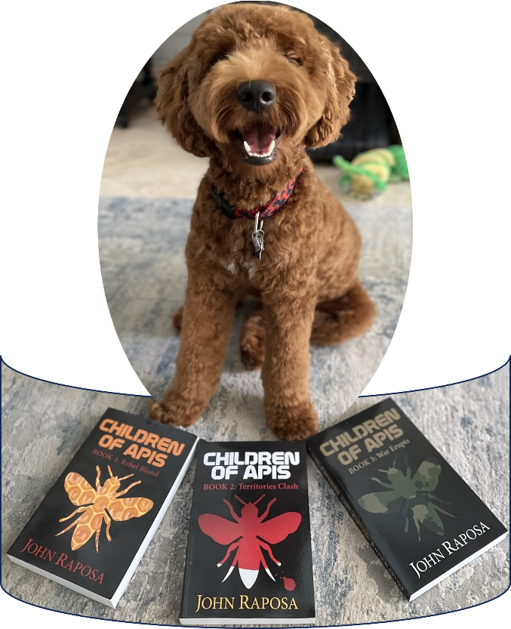

children of apis series


Book 1: Rebel Blood: Follow the plight of Cowan, Kenji, and friends as they search for answers in the Northeast Territory ruled by an iron-fisted general. How will our rebels cope in this dystopian society? Will they surrender to authority or follow in the footsteps of past rebel groups?

https://www.amazon.com/Children-Apis-Book-Rebel-Blood-ebook/dp/B01N5YHW6F



Book 2: Territories Clash: Elsewhere in the United States, territories are still healing from the eruption which nearly wiped out the entire population. Survivors are finding that life on the surface can be deadly when neighboring territories meet. Will the pockets of civilization band together, or will border wars bring the country to the brink of extinction?

https://www.amazon.com/gp/product/B076J3BJ9N

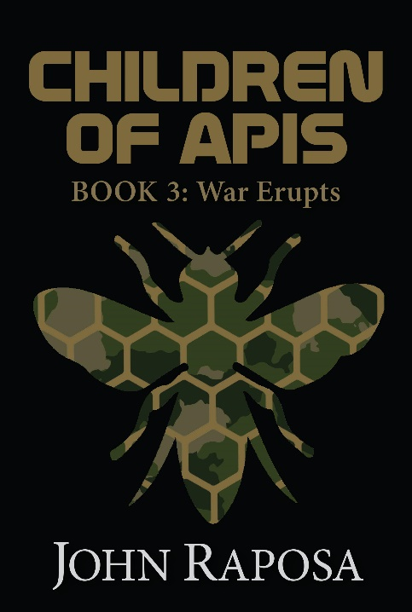

Book 3: War Erupts: The exciting conclusion to the Children of Apis series. Alliances have been made, and battle lines have been drawn. Which territory will prevail? Will a final war finish what the supervolcano started?

https://www.amazon.com/Children-Apis-Book-War-Erupts-ebook/dp/B07J2NPSBN

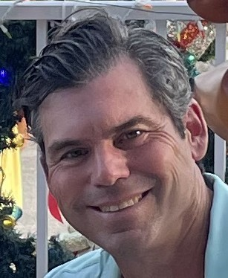
ABOUT THE AUTHOR
John Raposa lives in Osprey, Florida, with his wife, Ruth. He has two children, Shannon and Shaelyn, and two stepchildren, Baylee and Ian. He recently completed his fourth novel entitled “All in the Cards.” When he isn’t keeping his wife awake with the clicking of the keyboard, he is either playing with his two Mini Goldendoodles, Booker and Scout or working on his golf game.

Trilogy website: www.childrenofapis.com
Author E-mail: childrenofapis@gmail.com
Author Facebook: www.facebook.com/childrenofapis
Author Instagram: www.instagram.com/childrenofapis
Author Twitter: www.twitter.com/childrenofapis

